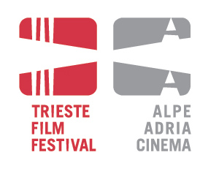

EASTWEEK
Film masters, new talents

Programme

JANUARY 21st, 2011
14.30 – Teatro Miela
Workshop of Stefano Tealdi (producer, Italy)
“No pitch, no money”

Presentation of the “Coproduction-prize for young German and Eastern European filmmakers” – by Frank W. Albers (Robert Bosch Stiftung)

17.30 – Teatro Miela
Eastweek showreel – the films of the Eastweek participants: AGRFT, Ljubljana

JANUARY 22nd, 2011
11.00 – Teatro Miela
Eastweek showreel – the films of the Eastweek participants: ASU, Sarajevo

14.30 – Teatro Miela
Lecture of Bernd Buder (film critic, Germany)
“Selling the cliché? Politics in recent Eastern European Cinema“

Presentation of the script-writing award “Mattador”

JANUARY 23rd, 2011
11.00 – Teatro Miela
Eastweek showreel – the films of the Eastweek participants: FDU, Belgrade

14.30 – Teatro Miela
Masterclass of Jiri Menzel (film director, Czech Republic)
“Why I make films and the necessity of comedies”

JANUARY 24th, 2011
11.00 – Teatro Miela
Eastweek showreel – the films of the Eastweek participants: VSMU, Bratislava

14.30 – Teatro Miela
Masterclass of Rade Serbedzija (actor, Croatia)
“The drama of close ups”

17.30 – Teatro Miela
Eastweek showreel – the films of the Eastweek participants: NATFA, Sofia and SZFE, Budapest

