



MEDIA Plus (2001-2006)
Call for proposals EACEA/02/06
Council Decision N° 2000/821/EC
amended by Decision N° 846/2004/EC
of the European Parliament and the Council

Application Form
for submitting proposals to obtain
Community funding for the implementation of
Pilot Projects

Conditions of Submission

1. Proposal language
All sections must be completed in one of the twenty official languages of the European Union. However, applicants are invited to supply a translation of the abstract and an extended summary of their proposal in English.

2. Submission form
Applications may only be submitted using this form. The Executive Agency will accept only typed forms which have not been modified and which have been completed correctly, in full. The annexes requested can be hand-written. Please respect the format provided and follow the page order. You are strongly advised to read through the entire application form before beginning to complete it.

This form is available on the Internet and can be downloaded (in word format) at the following address:
http://europa.eu.int/comm/avpolicy/media/pilot_en.html

The application comprises two parts and two annexes (see point 6.2 of the guidelines).

Part A collects administrative information about the proposal and its proposers (e.g. title of the proposed project, proposer’s names and addresses, brief description of the work, total funding requested by type of expenditure, etc…)

Part B (which unlike Part A is in the form of a structure or list of topics to be followed) asks for a detailed description of the nature of the proposed work. Part B should also identify and describe the partners and their responsibilities within the proposed project. Most importantly it should describe the contribution of the project in assisting the MEDIA Plus programme to attain its goals.

The annexes requested are necessary to provide the Executive Agency with additional administrative information to assist in the preparation of a contract if the proposal is successful.

3. The guidelines
Before completing the application form, please make sure you have read these guidelines. The Executive Agency reserves the right not to consider applications, which do not provide all of the information requested. Applications, which do not comply with the eligibility criteria detailed in these guidelines, will not be considered.

Applicants applying with a multi-annual project are requested to submit a detailed budget for each 12-month period, as well as a general forecast for the costs of subsequent year(s) of the project. Projects can last for periods of 12, 24 or 36 months but any contracts issued will always last for a maximum of 12 months.

Particular attention should be given to the Financial Guidelines. Any costs presented in the budget which do not comply with the Financial Guidelines will be considered as ineligible and will not be taken into account when calculating the support to be awarded.

4. Number of copies
Applicants are required to present one signed, initialled original application form completed with the requested annexes and two copies (including copies of the annexes.)

In addition to these, an electronic copy of the application shall be included on CD-Rom / DVD-Rom (no other formats accepted).

5. Deadline for reception
All applications must be sent by 17/07/2006. The postmark will be taken as proof of timely submission.

6. Presentation and delivery
All proposals must be clearly marked with the following words: “MEDIA PILOT PROJECTS EACEA/02/06”. The proposal’s short name (acronym) and the date of submission should be indicated at the top of every page of parts A and B and on every annex.

Proposals sent by registered mail should be sent to the following address:

Education, Audiovisual and Culture Executive Agency

Mr Constantin Daskalakis (office BOUR 03/30)

Head of MEDIA Unit (P8)

B - 1049 Brussels

Belgium

Applications delivered by hand or by private courier (which must be at the applicant's own expense) should be delivered to the following address:

Rue de Genève 1, B-1049 Brussels, Belgium

If sent by private courier, the date on the slip issued by the courier service will serve as proof of the date of posting;

If delivered by hand, a receipt signed and dated by the services of the Commission should be delivered.

Applicants are required to confirm the dispatch of an application before the deadline to the following fax number: +32 2 299 92 14.

Part A: Administrative Information

1- PROJECT FOR WHICH THE APPLICATION IS BEING MADE (double click in box to tick) (1)
ACTION 1 DISTRIBUTION: new ways of distributing and promoting European content via personalised services

ACTION 2 NETWORKED DATABASES to broaden and strengthen the access and the exploitation of archives and catalogues

ACTION 3 Previously funded Projects: projects which have received funding under a previous MEDIA Plus Pilot Project Call for Proposals

2- TITLE OF PROJECT
Project title:

Proposal’s short name (acronym):

Project N° (for office use only):

3- DURATION OF PROJECT (double click in box to tick)
12 Months
24 Months
36 Months

(1) The same application cannot be submitted for different areas.

4- ORGANISATION RESPONSIBLE FOR THE PROJECT (beneficiary of possible MEDIA support) (1)
Name:

Address:

Tel (Office):

Fax:

Tel (Mobile):

E-mail:

Legal status:

5- PERSON IN CHARGE OF THE PROJECT WITHIN THE ABOVE ORGANISATION (who will be authorised to sign the Agreement for MEDIA support if the application is selected) (1)
Name:

Job description:

Address:

Tel (Office):

Fax:

Tel (Mobile):

E-mail:

(1) If the project is selected, only the organisation designated in point 4 will be authorised to receive MEDIA support. Similarly, only the person in charge designated in point 5 will be authorised to sign the Agreement for MEDIA support. Any subsequent changes must be duly substantiated and are subject to prior approval by the Executive Agency.

6- PROJECT Partners
(If necessary, create lines to add more partners)
N° | Partner | Type of institution | Contact Person | Address | Phone | Fax | E-mail
1
2
3
4

7- BRIEF DESCRIPTION OF PROJECT (maximum 1000 characters)

8- PROJECT BUDGET
(Reproduce the table to show an overview of the costs for subsequent years, if necessary)
8.1- EXPENDITURE (1) | in EURO | % of total costs
1- Personnel costs

2- Operating costs

Travel and subsistence costs

Durable Equipment

Advertising and promotion

Cost of bank guarantee

3- Sub-contracting costs
(please specify)

4- Overheads (2)

TOTAL EXPENDITURE in EURO

(1) Specify unit costs and where relevant the number of persons concerned. Budget items of more than 10.000 EURO should be broken down in detail.
(2) Overheads costs should be presented as a lump sum which may not exceed 7% of the total eligible costs of the project.

8.2- INCOME | in EURO | % of total income
1- Own resources

2- Private sources
Indicate name of companies and amounts
(contributions in kind cannot be included here)

3- Public funds other than monies requested from the MEDIA Plus Programme
(Aid from local, regional, national and international sources - state organisation name)

4- Financial contribution requested from the MEDIA Plus Programme

TOTAL INCOME in EURO

The budget must be balanced, income (part 8.1), including the financial contribution requested from the MEDIA Plus Programme, matching expenditure (part 8.2). Otherwise the Executive Agency will not accept the application.

Part B: Presentation of the Proposed Project

9- OBJECTIVES
This section should not exceed two pages. The objectives should be achievable within this project, not through any subsequent developments, and should be quantifiable and verifiable. Evaluations will measure the progress of the project work against these objectives.
(To be continued on an additional sheet if necessary)

10- PROJECT WORK PLAN
This section, which should not exceed 20 pages, describes the work planned in order to achieve the objectives of the project. Essential elements of the work plan:
1. Introduction, explaining the structure of the work plan and the methodology that enables achievement of the project
2. Project plan, showing the timing of the work to be accomplished
3. Graphical presentation of the project’s components, illustrating their separate elements
4. Detailed project description including identification of significant risks and contingency plans.
(To be continued on additional sheets if necessary)

11- contribution to THE OBJECTIVES OF THE MEDIA PLUS PROGRAMME
This section, which should not exceed two pages, should identify which audiovisual priority issue the proposal addresses. It should also describe why the proposed project should be carried out at European level instead of at national level, for example if there is a need to create a critical mass in human or financial terms, or whether the project will bring together complementary expertise existing in different organisations.

This section should also describe how the proposed project will contribute to the implementation or evolution of one or more of the MEDIA Plus programme’s objectives.
(To be continued on an additional sheet if necessary)

12- Project management
This section, which should not exceed two pages, should describe the management structure and management actions for the project, the decision making structures to be applied, the communication flow within the grouping, the quality assurance measures to be implemented, and should demonstrate how changes will be controlled and any conflicts resolved.
(To be continued on additional sheets if necessary)

13- Description of participants
This section, should provide a short description of participating organisations and key persons involved:
1. Expertise and experience of the organisation (no more than two pages per organisation)
2. Short CVs of the key persons to be involved (each CV no more than one page)
- stating their title, role and function within the project
- indicating relevant experience, expertise and involvement in other European Commission projects
3. How organisations and key people complement each other (no more than one page)
(To be continued on additional sheets if necessary)

14- Economic development
This section, which should not exceed three pages, should highlight future plans. The project should clearly identify the conditions required to maximise project success. Strategic impact of the proposed project in terms of improvement of competitiveness or creation of markets and of market opportunities for the participants should be described. This should include assessment of market size, competition, pricing and potential sales.
(To be continued on additional sheets if necessary)

Annexes

Please fill in and attach the following annexes in the correct order as required:

- Annex I: Financial Identification (Bank detail sheet to be completed and signed by bank manager and authorised signatory of applicant organisation)
A template is available on: http://europa.eu.int/comm/budget/execution/ftiers_en.htm
- Annex II: Legal entity form
A template is available on: http://europa.eu.int/comm/budget/execution/legal_entities_en.htm
- Annex III: Financial Capacity form
- Annex IV: Declaration
- Annex V: Acknowledgement of Receipt

Annex I: Financial Identification

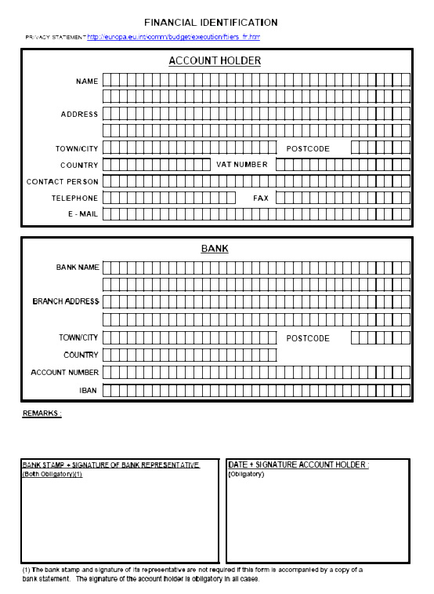
SPECIMEN
Annex II: Legal Entity Form

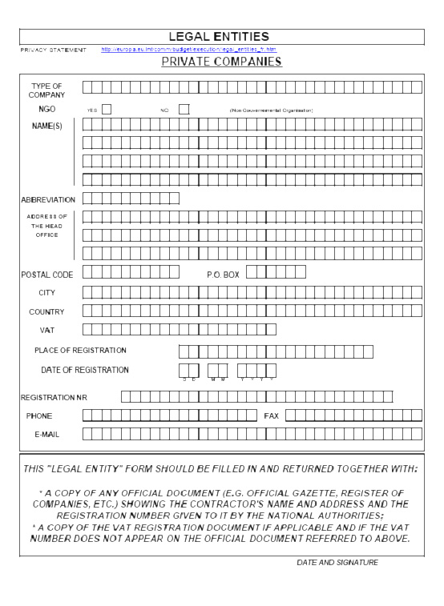
SPECIMEN
Annex III: Financial Capacity

Applicant certifies that it has enclosed the following document with the application:

Complete annual accounts (balance sheet, profit and loss accounts and, if available, all relevant annexes) of the applicant company

Approved by :
Board General Assembly
Other (please specify)……………………………………………………………………
Date:…………………… Signed by: ……………………………………………………….
Position: ……………………………………………………………………………………..

Certified by :
Approved Auditor in compliance with the 8th Directive 84/253/CEE
Name: ………………………………………………………..

The Applicant company must provide the following figures, based on the most recent complete certified accounts enclosed with this application:

Fiscal Year: ………………………………………………

Currency:

I – BALANCE SHEET

Assets Liabilities
Formation expenses: Equity capital:

Balance sheet total:

II – PROFIT AND LOSS ACCOUNT

Turnover:

Depreciation

Operating profit or loss:

Total expenses:

Profit or loss for the financial year after tax:

Date and signature of Applicant organisation’s authorised representative:

…………………………....

Annex IV: Declaration

I am fully aware that my organisation is not entitled to receive more than one grant from the European Community for the action covered by this application and will, therefore, withdraw my application for any other grant from the European Community should this application be successful, or will withdraw this application should any other application be successful.

I agree to the publication of information about the grant award, as published in the notice for this Call for Proposals, should my application be successful.

The applicant company certifies that it is not in one of the exclusion cases listed in point 2.1.1 of the Guidelines of Call for Proposals EACEA/02/06.

I certify that the information provided is truthful and accurate.

Date and place:

Signature of person responsible for the project (as stated in point 5)

Name of person responsible for the project:

Annex V: Acknowledgement of Receipt

Community funding for the implementation of Pilot projects

Education, Audiovisual and Culture Executive Agency

To be completed by the applicant

Address to which acknowledgement should be sent:

(Complete the right-hand column)

ACKNOWLEDGEMENT OF RECEIPT

To be completed by the applicant

Application form for project entitled:

Reference number to be quoted in all correspondence (will be attributed by the Executive Agency):

Education, Audiovisual and Culture Executive Agency

Checklist

This checklist will help you check that your proposal is complete and meets all the eligibility criteria and formal requirements of the programme. Your project will be evaluated only if your application fulfils all the following criteria:

Administrative information about the submitted Project and the applicant organisation (A.1 to A.5)

List of Partners (A.6) and a statement of intent from each partner designating the applicant organisation as the co-ordinator of the Project

Brief description of the Project (A.7)

Project Budget and Income (A.8.1 & A.8.2) broken down for every 12 months period

Project Objectives, Work plan and Contribution to the objectives of the MEDIA Plus Programme (B.9 to B.11)

Project Management and Description of Participants (B.12 & B.13), including CVs of the key persons involved in the Project

Economic Development (B.14)

Financial Identification Form (Annex I)

Legal Entity Form (Annex II), together with:
- a copy of the statutes of the applicant company
- the official registration document
- the VAT registration document

Financial Capacity Form (Annex III), together with:
- the balance sheet for the last fiscal year
- the profit & loss account for the last fiscal year
- when the requested contribution from MEDIA Plus is higher than € 300,000, the full audited accounts for the last fiscal year, certified by an approved auditor

Declaration signed and dated (Annex IV)

Acknowledgement of Receipt (Annex V)

Does your project fulfil the European dimension criterion?

Is the budget presented in conformity with the format and instructions of the application form?

Have all sections (of Part A & B) of your application been typed? (Hand-written documents are not acceptable)

Have you submitted one signed, initialled and dated original application form and two copies?

Have you included an electronic copy of the entire application on CD-Rom / DVD-Rom?

An explanatory note in the 20 official languages of the EU is available on the website http://europa.eu.int/comm/avpolicy/media/index_en.html
Formation expenses = all costs incurred for the establishment of the company (recorded in the intangible assets)
Equity capital = capital and reserves (called up shared capital + share premium account + profit & loss account)
Balance sheet total = total assets = total liabilities
The depreciation allowance is recorded in the operating expenses
Operating Profit is the difference between the Operating Income (excluding financial and extraordinary income) and the Operating Expenses (excluding financial and extraordinary charges). Please indicate whether this amount is positive (« + ») or negative (« - »).
Total expenses = total of operating expenses, financial charges, extraordinary charges and taxation charges.

