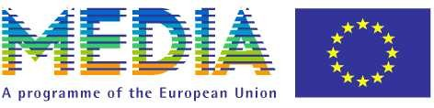

german-polish panel

Training Initiatives for media professionals / co-productions: experts` presentations and case study

Warszawa Film Festival

13. October 2006

13.30 Lunch

15:00 Welcome Joanna Wendorf, MEDIA Desk Warszawa
Susanne Schmitt, MEDIA Antenna Berlin-Brandenburg
Stefan Laudyn, Director of Warsaw Film Festival

Panel I Presentation of Training Initiatives

15:05 Presenter: Susanne Schmitt, MEDIA-Antenna Berlin-Brandenburg

BERLINALE TALENT CAMPUS, Dorothee Wenner
DISCOVERY CAMPUS, Donata v. Perfall
ELF, Andrea Peters, Erich Pommer Institut
EAVE, Tina Trapp
EQUINOXE, Bettina Gries
P.R.I.M.E., Frank Stheling, Transfocal GmbH
SOURCES 2, Julia Radke
NIPKOW, Uta Ganschow
MOONSTONE, Gabriele Brunnemeyer
INSIGHT OUT, Corinna Marschall

16:00 Q & A / One 2 One Meetings

16:30 Coffee & Talk / One 2 One Meetings to be continued

Panel II Key Notes of Training Experts

17:00 Presenter: Andrea Peters, EPI and Julia Radke, SOURCES 2

Simin Lange, Key Note on Checklist for Co-Production Agreements (EPI)
Gareth Jones, Scenario Films Ltd, Key Note on Development (Sources2),

Panel II I Case Study

18:00 Presenter: Dorota Pacciarelli, Deputy Director Polish Film Institute,
Introduction on German-Polish Co-Production

UNKENRUFE, Dtl /PL
Tba. Ziegler Film
Henryk Romanowski, Filmcontract Ltd.

19:00 Cent East Party on Invitation of Stefan Laudin, Director Film Festival Warszawa

