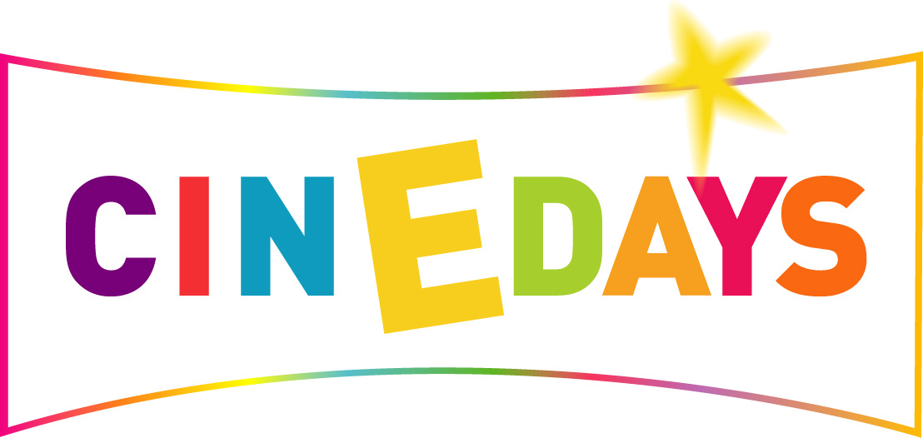

CinEdays Europe 2003

Partnership Agreement

From 10-24 October, Europe will celebrate film with ‘Cinedays Europe 2003,’ an initiative from Viviane Reding, European Commissioner for Education and Culture.

Cinedays objectives are twofold :

- To enable Europeans, especially young people, to (re)discover the treasures of European cinema, to deepen their understanding of their own cinematographic culture or simply their knowledge of Europe
- To raise the profile of European Film Heritage in all its rich diversity

In addition to programming classic European films in cinemas and across television networks, this initiative will allow young people to improve their knowledge of cinematic heritage and of ‘the image,’ through a programme of events carried out by schools, film institutes and other educational and cultural bodies.
Become a Partner of Cinedays Europe

- You are a local authority

- You are the owner of a cinema or the head of a film institute

- You are a distributor, a video and DVD renter,

- You are the head of a cultural, social or educational association or of a film club or any other centre for young people

- You produce either a web site, a radio programme, a magazine or a review dedicated to film

- You love cinema and wish to publicise your film activities beyond your area, your city, your region and your country while participating in a Europe-wide event

Then Cinedays is for you!

From 10 - 24 October 2003 Cinedays will celebrate European Film Heritage and Cinematography. Bringing together cinemas, film institutions, television broadcasters, towns, education and cultural institutions and associations supported by the European Union.

You can participate by:

- Screening programmes of / about Classic European Film
- Promoting Cinedays to fellow citizens, via your own information networks (magazines, newspapers or bulletins, web sites, direct mail-outs or through partnerships with other institutions)
- Organising or hosting events and discussions which valorise and promote European cinema to young people

In return, you will benefit from:

- Promotion of your initiatives on the European Commission web sites (including links to your site); mention of your project in documentation and Press Releases distributed by our networks across Europe.
- Inclusion of your initiative in the general Cinedays programme
- Free publicity material: post cards, the Cinedays graphic in electronic format, a 30 second trailer, the right to use the Cinedays and European Union logos for non-commercial purposes.

Cinedays Partnership

Company Name:

Sector:

Head of Cinedays project management :

Name:
Job Title:
Contact Details: Tel
Fax
E-mail

Description of your activity /project for Cinedays:

Dates of your programme:

Other useful information:

To become a Cinedays partner, please return the completed form along with your logo, in electronic format (. tiff, jpeg) to:

Marielle Riché
European Commission
Directorate General for Education and Culture
eac-info@cec.eu.int
Fax: + (32.2) 296 73 58

Cinedays: http://www.cineuropa.org

