



MEDIA 2007 (2007-2013)

CALL FOR PROPOSALS EACEA 34/2012

APPLICATION FORMS

i2i AUDIOVISUAL

Please read carefully the Permanent Guidelines 2012 – 2013 – version 2.0

Application Form (in WORD)
To be completed and signed by the applicant company
Check List
The following documents must be submitted in one original copy

Applications failing to supply the necessary documents may be considered ineligible.

I. Identification of the Applicant Company

Copy of all registered documents officially establishing the company, together with copies of any subsequent amendments, including proofs of the company registration number, the full legal title of the organisation, the registered address and the legal signatory and a complete list of all shareholders / Management Board certifying their nationalities (Form I.a.and II).

Copy of VAT registration documents.

Completed and signed by the applicant company and the bank copy of Form I.b. ‘Bank Information form,’ ensuring that all details correspond with information set out in the registered documents provided.

Signed, completed copy of Form I.c. ‘Legal Status,’ ensuring that all details correspond with information set out in the registered documents provided

II. Declarations

Signed declaration (Annex III).

Declaration of the co-producers designating the applicant producer as the delegate producer in the case of a contract with the EACEA.

III. Information concerning the Project

A declaration concerning the rights to the work:
- if the project is an original work, a declaration by the author and the applicant producer certifying that the work does not infringe the rights of any third party
- if the project is an adaptation upon copyrighted material, a contract between the rights holder or agent and the applicant producer.

A work plan (specifying all the stages for the production of the work).

Signed co production agreement(s) or deal-memo(s), including any appendices and amendments.
.
Signed distribution agreement(s) or signed binding letters of commitments and where appropriate with an international sales agent.

IV. forecast financial statement ((in excel)

Summary of Forecast Expenses & Incomes
Forecast Production Budget (Annex V.a.).
Forecast Financial Plan, specifying all the requested details (Annexe V.b.)

V. Information concerning the Modules

Modules Table.
Table that indicates the applicant’s choice of Modules and the requested amount. (Maximum € 50 000, the amounts filled in this table must correspond to the ones of the provisional budget and financial plan) (Annex VI.a.)

For Module 1
Summary insurance Table (Annex VI.b.)
Copy of the insurance policies, riders, endorsements signed binding letter(s) of commitment(s) or deal memo(s).
Copy of receipt(s) paid, if applicable.

For Module 2
Copy of the Completion Guarantee, signed binding letter(s) of commitment(s) or deal memo(s).
Copy of receipt(s) paid, if applicable.

AND

Copy of the Completion Agreement, binding letter(s) of credit signed by a credit or financial institution.
Copy of receipt(s) paid, if applicable.

For Module 3
Copy of the full bank financing agreement, including the cash flow schedule or an estimate of the financial costs made by the bank.
Copy of receipt(s) paid, if applicable.

VI. Acknowledgement of Receipt (Annex VI)

VII. Table of Equivalence relative to Company Documents

I.a. Identification of the Company

Full legal name of the Company:
Short name (where applicable)
Acronym (where applicable)
Legal Status (association, commercial company…)
Foundation date:
Activity:
VAT No.
Legal Registration No:
Statutory Legal Representative (enclose CV):
Position in the company:
The information stated will be used to establish the contract between the Agency and the applicant if selected. Please mention the complete name and legal status of the company along with the statutory legal representative.

Address of the registered office:
Street: . Tel:
Town: Fax:
Post Code: Country E-mail:

Address for correspondence (if different):
Street: Tel: .
Town: Fax:
Post Code: Country E-mail:

Name of the legal representative: | Position in the Company:
Signature of the legal representative: | Date:

I.b. Financial Identification
PLEASE USE THE RELEVANT FORM AVAILABLE ON THE WEBSITE:
http://ec.europa.eu/budget/contracts_grants/info_contracts/financial_id/financial_id_en.cfm

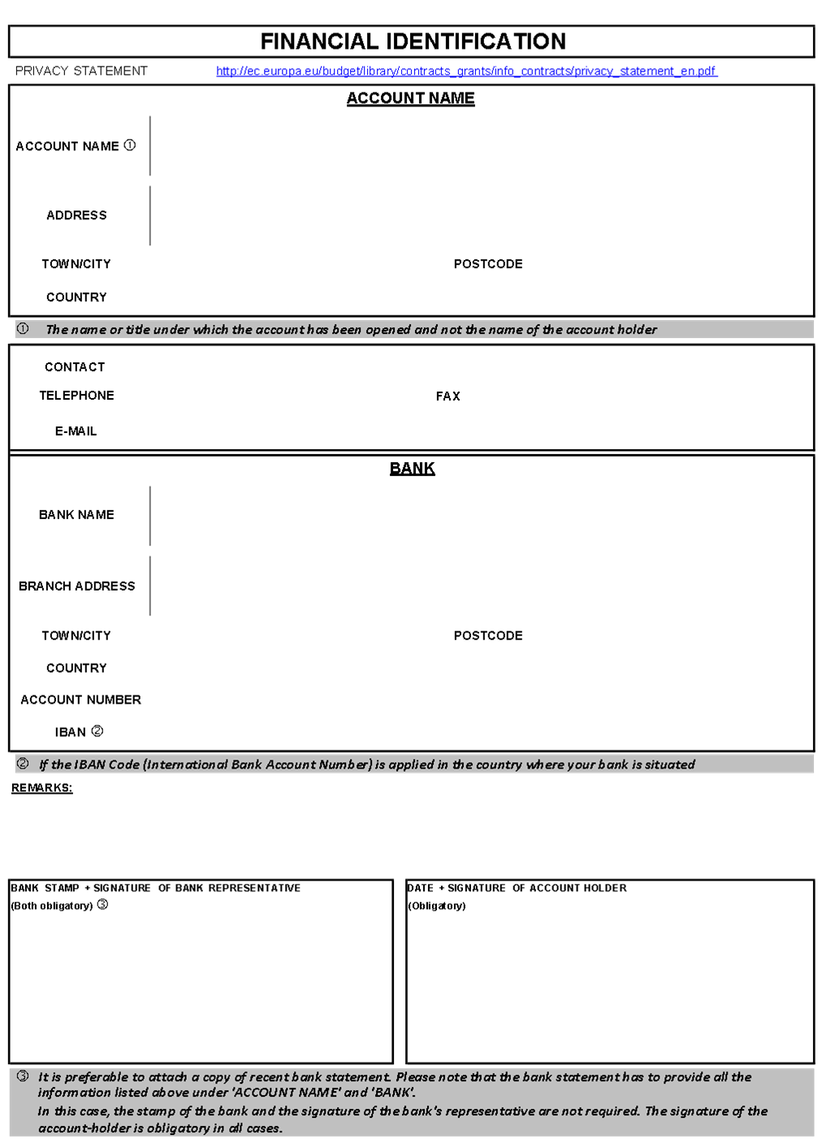

I.c. Applicant Identification Form (Legal Status)
PLEASE USE THE RELEVANT FORM AVAILABLE ON THE WEBSITE:
http://ec.europa.eu/budget/contracts_grants/info_contracts/legal_entities/legal_entities_en.cfm
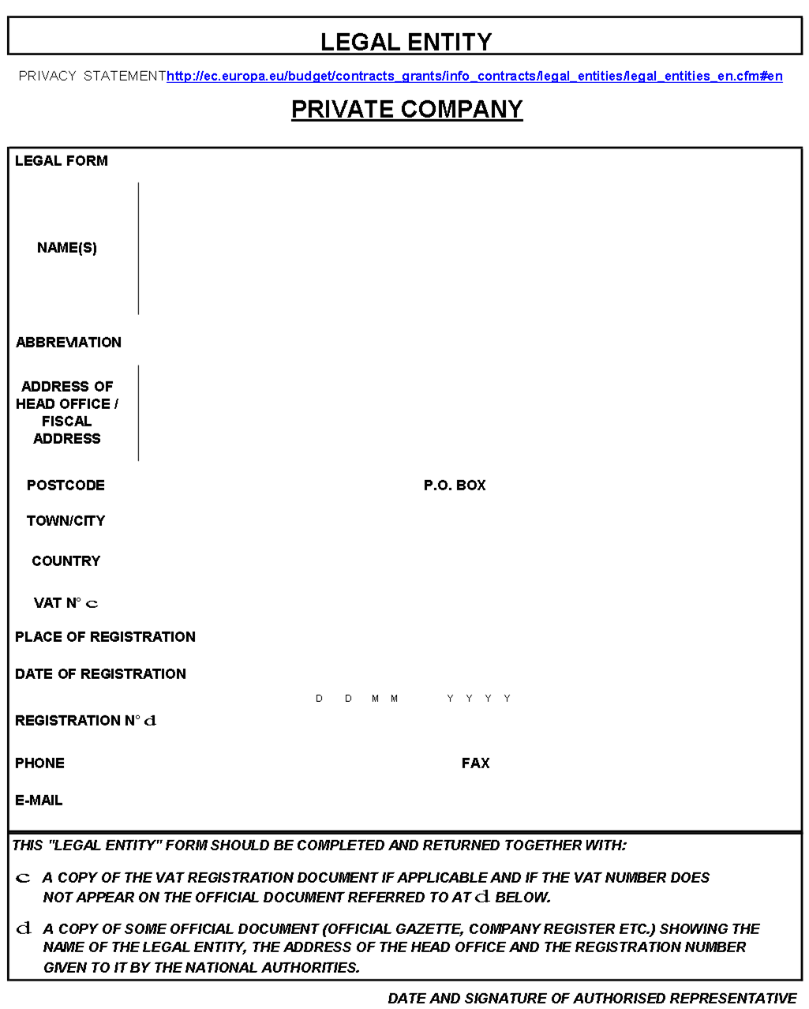
II. Information concerning the Company

Contact person for this project:
Contact Person:
Position in the company:
Phone: Fax:
email:

Company personnel:
Managing Director:
Head of Finance:
Number of employees: permanent: temporary:

Shareholders of first rank:
Name of shareholder Nationality % shareholding

Shareholders of second rank:
State precisely on an explanatory sheet the information requested to prove that the company is held either directly, or by majority share by citizens of Member states of the European Union and established in those countries. In the case of insufficient information, the producer may be considered as ineligible.

Existing subsidiaries of the company:
Name of Company Country Main activity % shareholding
................
................
................

Activities of the company during the last 12 months:
Production (including co-productions):
in pre-production

in production

productions completed

Other activities

Works produced or co-produced by the company in 2010 and 2011:

TITLE | Year of production | Category | Duration | Territories sold | Revenues

III. Declaration

Declaration

The applicant company certifies:

I the undersigned……….…….………………….............declare that I am the authorised signatory for the applicant company and guarantee on my honour that:

CONCERNING THE APPLICANT COMPANY:

- the information contained in the application forms and annexes is complete and correct, according to the terms defined in the guidelines for this Call for Proposals;

- that the applicant company is familiar with the guidelines “i2i AUDIOVISUAL” 2012-2013 of the MEDIA 2007 Programme and that it accepts and observes the conditions and procedures specified therein, particularly regarding co-financing;

- that the applicant company is an European independent production company as defined in section '5.1 Eligible companies' of the guidelines applicable to call for proposals EACEA 34/2012;

- that the person signing this application has been duly authorised by the company to do so;

CONCERNING THE ACTION :

* that the work proposed does not consist of advertising, pornographic or racist material, or advocates violence.

I am fully aware that my organization is not entitled to receive more than one grant from the European Union Budget for the action covered by this application and will therefore withdraw any application for any other grant from the European Union Budget should this application be successful, or will withdraw this application should any other application be successful.

I also agree to the publication of information about the grant award, should my application be successful.

Name of the legal representative: | Position in the Company:
Signature of the legal representative: | Date:

IV. Information concerning the Project

In the event that more than one project is proposed, forms III to VII (including all the corresponding Annexes) must be completed for each project.

Title:
Original Title:

Cast and crew list:

Director:
Name: Nationality / Residence:

This film is the director’s:

1st feature film 2nd feature film Other

Script Writer:
Name: Nationality / Residence:
Main cast:
Name: Nationality / Residence:
Name: Nationality / Residence:
Name: Nationality / Residence:
Composer:
Name: Nationality / Residence:
Production design (art direction):
Name: Nationality / Residence:
Director of photography:
Name: Nationality / Residence:
Editor:
Name: Nationality / Residence:
Sound:
Name: Nationality / Residence:

Shooting location: Country:

Laboratory: Country:

Genre:

Fiction cinema TV Drama Animation cinema Animation TV

Documentary
Format: Length (in minutes):
First day of principal photography (date):

Was the development of the project supported (Slate Funding, Single Project or New Talent) within the framework of the MEDIA Programme?

YES – SF YES – SP YES – NT NO

If YES, please indicate the MEDIA Development contract number:
Contract n°:

Is the project supported under the TV Broadcasting scheme within the framework of the MEDIA Programme?

YES NO

Is the project supported under the MEDIA Production Guarantee Fund within the framework of the MEDIA Programme?

YES NO

Log line of the project (max 3 lines) N.B. This information may be made publicly available.
…………………………………………………………………………………………………………
…………………………………………………………………………………………………………
…………………………………………………………………………………………………………

Description of the project (in English or French): (Enclose a synopsis / treatment)

International Distribution Potential:
Please note that the items below should be completed as a minimum requirement. If necessary, additional information should be provided on a separate sheet. This is information will be used for the assessment of the award criteria "International distribution Potential" (if this is considered necessary in the course of the evaluation procedure)

1. International distribution company(-ies)/sales agent(s) involved and character of deals (territories, Minimum guarantees, terms etc.)

2. Your assessment of the International distribution potential of the project:

.

.

.

.

.

.

3. Marketing Strategy:
3.1. Intended focus-point territories, specific reformatting/dubbing/subtitling for intended territories

3.2. Intended Promotional Activities
:

3.3. Intended trade fair/festival attendance:

……………………………………………………………………………………………………
……………………………………………………………………………………………………
……………………………………………………………………………………………………
……………………………………………………………………………………………………
……………………………………………………………………………………………………........................................................................................................................................................

Co-production agreement(s)
Please indicate the country of origin of the co-production companies:
Are you the majority producer?
YES |  |  | NO
Are there any co-producer(s) bringing eligible costs to the budget or costs that will not be invoiced to the applicant company (this company will enter in the eventual agreement as co-beneficiary)?
YES |  |  | NO
If YES, please specify the name of the company, the legal representative, the legal address, the Vat N° - the Legal registration N°, the Module N° to which your co-producer(s) will bring eligible costs, the reference of financing institutions / agreement and the related amount.
 | Name of company / Legal representative | Legal address |  | VAT N° / Legal registration N°: | Module (1,2, 3) | Reference of financing Institution / Agreement | Amount  (EUR)
Co-producer 1

Co-producer 2

Co-producer 3

Co-producer 4

Annex VII – Acknowledgement of Receipt

This page will be returned to you when the EACEA has received your application. Therefore, please complete the information below clearly:

To be completed by the applicant

Project Title:
Company Name:

Contact Person:
Address:

Fax Number (to which this acknowledgement should be sent):

To be completed by the EACEA

Date:
Application Reference number to be quoted in all correspondence:

Annex VIII– Table of Equivalence relative to Company Documents

Country | Certificate of Company Registration | Memorandum of Association
Austria | - Firmenbuch-Auszug  - Auszug aus dem Handelsregister | Einbringungs- und Gesellschaftsvertrag
Belgium | - Extrait du Moniteur Belge  - Uittreksel uit het Belgisch Staatsblad | - Statuts  - Statuten
Bulgaria | УДОСТОВЕРЕНИЕ / удостоверение | РЕШЕНИЕ / решение
Croatia | Podaci Za Upis U Glavnu Knjigu Sudskog Registra | Statut
Cyprus | ΠΙΣΤΟΠΟΙΗΤΙΚΟ ΣΥΣΤΑΣΗΣ / Πιστοποιητικό Σύστασης | ΙΔΡΥΤΙΚΟ ΚΑΤΑΣΤΑΤΙΚΟ ΕΓΓΡΑΦΟ / Ιδρυτικό Καταστατικό Έγγραφο
Czech Republic | Výpis z Obchodního Rejstříku | Zakladatelská Smlouva
Denmark | Erhvervs- og Selskabsstyrelsen (Sammenskrevet Resume) | Vedtægter
Estonia | Äriregistri B-osa Registrikaart | Põhikiri
Finland | Kaupparekisteriote | Yhtiöjärjestys
France | Extrait K-Bis | Statuts
Germany | Auszug aus dem Handelsregister | - Gesellschaftsvertrag zur Gründung einer Gesellschaft  - Urkunde
Greece | - ΦΥΛΛΟ ΕΦΗΜΕΡΙΔΑΣ ΤΗΣ ΚΥΒΕΡΝΗΣΕΩΣ (ΦΕΚ) / Φύλλο Εφημερίδας της Κυβερνήσεως  - ΕΝΑΡΞΗ / Έναρξη | ΚΑΤΑΣΤΑΤΙΚΟ / Καταστατικό
Hungary | Cégkivonat | Társasági Szerződés
Iceland | Nýleg staðfesting frá Hlutafélagaskrá, Hagstofu Íslands | - Stofnskrá  - Stofnsamningur
Ireland | Certificate of Company Registration + Annual Return to Companies Registration Office: Form B1 | Memorandum and Articles of Association + Certification of shareholding by chartered accountants
Italy | Certificato della Camera di Commercio | Statuto
Latvia | Reğistrācijas Apliecība | Statūti
Lithuania | Registravimo Pažymėjimas | statai
Luxemburg | Extrait du Registre de Commerce et des Sociétés | Statuts
Malta | Certificate from the Registry of Companies – Malta | Memorandum of Association
Netherlands | Uittreksel uit het Handelsregister van de Kamer van Koophandel | Statuten
Norway | Brønnøysundregistrene Firmaattest | Vedtekter
Poland | Odpis z Krajowego Rejestru Sądowego - KRS + REGON | Zaświadczenie o Wpisie do Ewidencji Działalności Gospodarczej
Portugal | Certidão du Registo Comercial | Constituição da Sociedade
Slovakia | Výpis z Obchodného Registra | Osvedčenie o Založení
Slovenia | Obvestilo o Identifikaciji in Razvrstitvi po Dejavnosti | Vpis v Sodni Register + Redni Izpisek iz Sodnega Registra
Spain | Certificado de Inscripción en el Registro Mercantil | Escritura de Constitución de Sociedad
Switzerland | - Handelsregisterauszug  - Extrait du registre de commerce  - Estratto del Registro di commercio | - Statuten  - Statuts  - Statuto
Sweden | Registreringsbevis från Bolangsverket | Bolagsordning
United Kingdom | Certificate of Company Registration + Annual Return to Companies House: Form 363s | Memorandum and Articles of Association + Certification of shareholding by chartered accountants
Romania | Certificat de inregistrare la Oficiul National al Registrului Comertului. | Statut

Country Abbreviation: Austria - AT, Belgium - BE, Bosnia and Herzegovina - BA, Bulgaria - BG, Croatia - HR, Cyprus - CY, Czech Republic - CZ, Denmark - DA, Estonia - EE, Finland - FI, France - FR, Germany - DE, Greece - EL, Hungary - HU, Ireland - IE, Iceland - IS, Ireland - IE, Italy - IT, Liechtenstein - LI, Latvia - LV, Lithuania – LT, Luxembourg - LU, Malta - MT, Norway - NO, the Netherlands - NL, Poland - PL, Portugal - PT, Romania - RO, Slovakia - SK, Slovenia – SI, Spain -ES, Sweden - SU, Switzerland – CH, the United Kingdom - UK. More information at http://publications.europa.eu/code/en/en-370100.htm

