Application Form
To be completed and signed by the applicant company
Check List
The following documents must be submitted in one original copy

Applications failing to supply the necessary documents may be considered ineligible.

I. Identification of the Applicant Company

Copy of all registered documents officially establishing the company, together with copies of any subsequent amendments, including proofs of the company registration number, the full legal title of the organisation, the registered address and the legal signatory and a complete list of all shareholders / Management Board certifying their nationalities (Form I.a.and II).

Copy of VAT registration documents.

Completed and signed by the applicant company and the bank copy of Form I.b. ‘Bank Information form,’ ensuring that all details correspond with information set out in the registered documents provided.

Signed, completed copy of Form I.c. ‘Legal Status,’ ensuring that all details correspond with information set out in the registered documents provided

Curriculum vitae of the legal representative (or the managing director) and the main collaborators.

II. Declarations

Signed declaration (Annex III).

Declaration of the co-producers designating the applicant producer as the delegate producer in the case of a contract with the EACEA

III. Information concerning the Project

A declaration concerning the rights to the work:
- if the project is an original work, a declaration by the author and the applicant producer certifying that the work does not infringe the rights of any third party
- if the project is an adaptation upon copyrighted material, a contract between the rights holder or agent and the applicant producer.

A work plan (specifying all the stages for the production of the work)

IV. Provisional Budget Summary Form (Excel)

Provisional Production Budget (Annex V.a.)
Provisional Financial Plan, specifying all the requested details (Annexe V.b.)

V. Information concerning the Modules

Modules Table.
Table that indicates the applicant’s choice of Modules and the requested amount. (Maximum € 50 000, the amounts filled in this table must correspond to the ones of the provisional budget and financial plan) (Annex VI.a.)

For Module 1
Summary insurance Table (Annex VI.b.)
Copy of the insurance policies

For Module 2
Copy of the Completion Guarantee
AND
Copy of the Completion Agreement

For Module 3
Copy of the full bank financing agreement, including the cash flow schedule or an estimate of the financial costs made by the bank

VI. Acknowledgement of Receipt (Annex VI)

VII. Table of Equivalence relative to Company Documents

I.a. Identification of the Company

Full legal name of the Company:
Short name (where applicable)
Acronym (where applicable)
Legal Status (association, commercial company…)
Foundation date:
Activity:
VAT No.
Legal Registration No:
Statutory Legal Representative (enclose CV):
Position in the company:
The information stated will be used to establish the contract between the Agency and the applicant if selected. Please mention the complete name and legal status of the company along with the statutory legal representative.

Address of the registered office:
Street: . Tel:
Town: Fax:
Post Code: Country E-mail:

Address for correspondence (if different):
Street: Tel: .
Town: Fax:
Post Code: Country E-mail:

Name of applicant: Position in the Company:

Signature of the statutory
legal representative: Date:

I.b. FINANCIAL IDENTIFICATION
PRIVACY STATEMENT http://ec.europa.eu/budget/execution/ftiers_fr.htm

ACCOUNT  NAME⁽¹⁾  ADDRESS  TOWN/CITY  COUNTRY | ACCOUNT NAME
ACCOUNT  NAME⁽¹⁾  ADDRESS  TOWN/CITY  COUNTRY |  | POSTCODE

CONTACT
TELEPHONE |  | FAX
E - MAIL

 | BANK
BANK NAME
BRANCH ADDRESS
TOWN/CITY |  | POSTCODE
COUNTRY
ACCOUNT NUMBER
IBAN(²)
DATE + SIGNATURE ACCOUNT HOLDER :
(Obligatory)
DATE
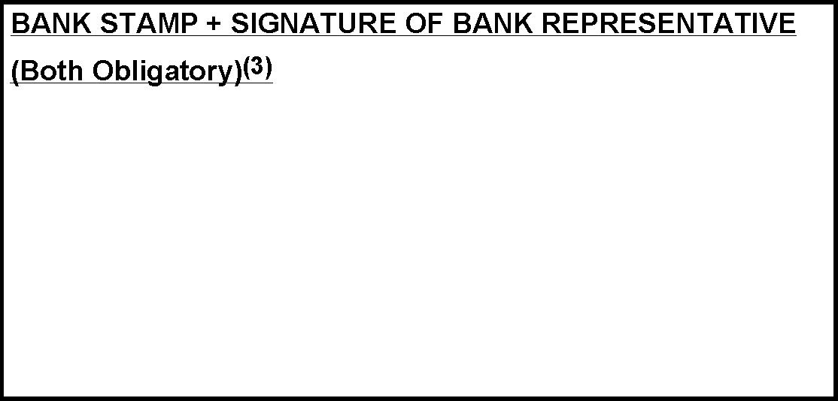
REMARKS:
⁽¹⁾ The name or title under which the account has been opened and not the name of the authorized agent
⁽²⁾ If the IBAN Code (International Bank accout number) is applied in the country where your bank is situated
⁽³⁾ It is preferable to attach a copy of recent bank statement, in which event the stamp of the bank and the signature of the bank's representative are not required. The signature of the account-holder is obligatory in all cases.

This form is available at: http://ec.europa.eu/budget/execution/ftiers_fr.htm

I.c. Applicant Identification Form (Legal Status)

SPECIMEN

PLEASE USE THE FORM RELEVANT TO THE NATURE OF THE APPLICANT ORGANISATION. THESE FORMS ARE AVAILABLE ON THE WEBSITE:
http://ec.europa.eu/budget/execution/legal_entities_en.htm

II. Information concerning the Company

Contact person for this project:
Contact Person:
Position in the company:
Phone: Fax:
email:

Company personnel:
Managing Director:
Head of Finance:
Number of employees: permanent: temporary:

Shareholders of first rank:
Name of shareholder Nationality % shareholding

Shareholders of second rank:
State precisely on an explanatory sheet the information requested to prove that the company is held either directly, or by majority share by citizens of Member states of the European Union and established in those countries. In the case of insufficient information, the producer may be considered as ineligible.

Existing subsidiaries of the company:
Name of Company Country Main activity % shareholding
................
................
................

Activities of the company during the last 12 months:
Production (including co-productions):
in pre-production

in production

productions completed

Other activities

Works produced or co-produced by the company in 2007 and 2008:

TITLE | Year of production | Category | Duration | Territories sold | Revenues

III. Declaration

Declaration

The applicant company certifies:

- that it is familiar with the guidelines “i2i Audiovisual” of Call 29/2007 of the MEDIA Programme and that it accepts and observes the conditions and procedures specified therein, particularly regarding co-financing;
- that it is not in one of the exclusion cases listed in section 6 of the guidelines of Call for proposals 28/2008;
- that it is a European Independent production company as defined in the guidelines applicable to this Call;
- that the work proposed ………………………………………………………….(project title) does not consist of advertising, pornographic or racist material, nor advocates violence;
- that the information contained in this application form are true and verifiable;
- that the person signing this application has been duly authorised by the company to do so;
- that it agrees with the publication of information about the grant awarded, should its application be successful;
- that it is fully aware that its organisation is not entitled to receive more than one grant from the Agency for the action covered by this application and will therefore withdraw any other application for any other grant from the Agency should this application be successful, or will withdraw this application should any other application be successful;
- that it has read the checklist below and supplied all of the documentation requested;
- that it has the financial and operational capacity to carry out the submitted project.

Name of applicant: Position in the Company:

Signature of the statutory
legal representative: Date:

IV. Information concerning the Project

In the event that more than one project is proposed, forms III to VII (including all the corresponding Annexes) must be completed for each project.

Title:
Original Title:

Cast and crew list:

Director:
Name: Nationality / Residence:

This film is the director’s:

1st feature film 2nd feature film Other

Script Writer:
Name: Nationality / Residence:
Main cast:
Name: Nationality / Residence:
Name: Nationality / Residence:
Name: Nationality / Residence:
Composer:
Name: Nationality / Residence:
Production design (art direction):
Name: Nationality / Residence:
Director of photography:
Name: Nationality / Residence:
Editor:
Name: Nationality / Residence:
Sound:
Name: Nationality / Residence:

Shooting location: Country:

Laboratory: Country:

Genre:

Fiction cinema Fiction TV Animation cinema Animation TV

Documentary
Format: Length (in minutes):
First day of principal photography (date):

Was the development of the project supported (Slate Funding, Single Project or New Talent) within the framework of the MEDIA Programme?

YES – SF YES – SP YES – NT NO

If YES, please indicate the MEDIA Development contract number:
Contract n°:

Is the project supported under the TV Broadcasting scheme within the framework of the MEDIA Programme?

YES NO

Description of the project (in English or French): (Enclose a synopsis / treatment)

International Distribution Potential:
Please note that the items below should be completed as a minimum requirement. If necessary, additional information should be provided on a separate sheet. This is information will be used for the assessment of the award criteria "International distribution Potential" (if this is considered necessary in the course of the evaluation procedure)

1. International distribution company(-ies)/sales agent(s) involved and character of deals (territories, Minimum guarantees, terms etc.)

2.Your assessment of the International distribution potential of the project:

.

.

.

.

.

.

3.Marketing Strategy:
3.1. Intended focus-point territories, specific reformatting/dubbing/subtitling for intended territories

3.2. Intended Promotional Activities
:

3.3. Intended trade fair/festival attendance:

Are there any co-producers bringing eligible costs to the budget or costs that will not be invoiced to the applicant company (this company will enter in the eventual agreement as co-beneficiary)?

YES NO

If YES, please indicate the name of the company, the legal representative, the legal address and correspondence data of the co-producer.

Co-producer 1:
Name of the company:…………………………………………………………………………….
Legal representative: ……………………………………………………………………………..
Legal address:……………………………………………………………………………………..
………………………………………………………………………………………………………
VAT N°: ………………………….. Legal registration N°: …………………………………….
Phone:………………………………………………………………………………………………
Fax: ………………………………………………………………………………………………...
Email:………………………………………………………………………………………………

Co-producer 2:
Name of the company:…………………………………………………………………………….
Legal representative: ……………………………………………………………………………..
Legal address:……………………………………………………………………………………..
……………………………………………………………………………………………………..
VAT N°: ………………………….. Legal registration N°: …………………………………….
Phone:……………………………………………………………………………………………..
Fax: ………………………………………………………………………………………………... Email: ……………………………………………………………………………………………

Annex VII – Acknowledgement of Receipt

This page will be returned to you when the EACEA has received your application. Therefore, please complete the information below clearly:

To be completed by the applicant

Project Title:
Company Name:

Contact Person:
Address:

Fax Number (to which this acknowledgement should be sent):

To be completed by the EACEA

Date:
Application Reference number to be quoted in all correspondence:

EACEA

Annex VIII– Table of Equivalence relative to Company Documents

Country | Certificate of Company Registration | Memorandum of Association
Austria | - Firmenbuch-Auszug  - Auszug aus dem Handelsregister | Einbringungs- und Gesellschaftsvertrag
Belgium | - Extrait du Moniteur Belge  - Uittreksel uit het Belgisch Staatsblad | - Statuts  - Statuten
Bulgaria | УДОСТОВЕРЕНИЕ / удостоверение | РЕШЕНИЕ / решение
Cyprus | ΠΙΣΤΟΠΟΙΗΤΙΚΟ ΣΥΣΤΑΣΗΣ / Πιστοποιητικό Σύστασης | ΙΔΡΥΤΙΚΟ ΚΑΤΑΣΤΑΤΙΚΟ ΕΓΓΡΑΦΟ / Ιδρυτικό Καταστατικό Έγγραφο
Czech Republic | Výpis z Obchodního Rejstříku | Zakladatelská Smlouva
Denmark | Erhvervs- og Selskabsstyrelsen (Sammenskrevet Resume) | Vedtægter
Estonia | Äriregistri B-osa Registrikaart | Põhikiri
Finland | Kaupparekisteriote | Yhtiöjärjestys
France | Extrait K-Bis | Statuts
Germany | Auszug aus dem Handelsregister | - Gesellschaftsvertrag zur Gründung einer Gesellschaft  - Urkunde
Greece | - ΦΥΛΛΟ ΕΦΗΜΕΡΙΔΑΣ ΤΗΣ ΚΥΒΕΡΝΗΣΕΩΣ (ΦΕΚ) / Φύλλο Εφημερίδας της Κυβερνήσεως  - ΕΝΑΡΞΗ / Έναρξη | ΚΑΤΑΣΤΑΤΙΚΟ / Καταστατικό
Hungary | Cégkivonat | Társasági Szerződés
Iceland | Nýleg staðfesting frá Hlutafélagaskrá, Hagstofu Íslands | - Stofnskrá  - Stofnsamningur
Ireland | Certificate of Company Registration + Annual Return to Companies Registration Office: Form B1 | Memorandum and Articles of Association + Certification of shareholding by chartered accountants
Italy | Certificato della Camera di Commercio | Statuto
Latvia | Reğistrācijas Apliecība | Statūti
Lithuania | Registravimo Pažymėjimas | Įstatai
Luxemburg | Extrait du Registre de Commerce et des Sociétés | Statuts
Malta | Certificate from the Registry of Companies – Malta | Memorandum of Association
Netherlands | Uittreksel uit het Handelsregister van de Kamer van Koophandel | Statuten
Norway | Brønnøysundregistrene Firmaattest | Vedtekter
Poland | Odpis z Krajowego Rejestru Sądowego - KRS + REGON | Zaświadczenie o Wpisie do Ewidencji Działalności Gospodarczej
Portugal | Certidão du Registo Comercial | Constituição da Sociedade
Slovakia | Výpis z Obchodného Registra | Osvedčenie o Založení
Slovenia | Obvestilo o Identifikaciji in Razvrstitvi po Dejavnosti | Vpis v Sodni Register + Redni Izpisek iz Sodnega Registra
Spain | Certificado de Inscripción en el Registro Mercantil | Escritura de Constitución de Sociedad
Sweden | Registreringsbevis från Bolangsverket | Bolagsordning
United Kingdom | Certificate of Company Registration + Annual Return to Companies House: Form 363s | Memorandum and Articles of Association + Certification of shareholding by chartered accountants
Romania | Certificat de inregistrare la Oficiul National al Registrului Comertului. | Statut

