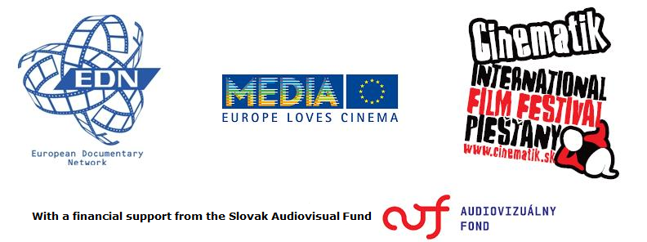

COPRODUCING DOCUMENTARIES IN EUROPE

International seminar & workshop

Organizers
IFF Cinematik Piešťany
European Documentary Network
MEDIA Desk Slovakia

APPLICATION FORM

6. & 7. September 2012
Kursalon, Piešťany / Slovakia

FIRST NAME & SURNAME: ................................................................................................................

COMPANY: ...................................................................................................................................................

ADDRESS: .....................................................................................................................................................

PHONE No.: ................................................................................................................................................

E-MAIL: .........................................................................................................................................................

□ I apply WITH A PROJECT (deadline: 20th July 2012)
□ I apply WITHOUT A PROJECT (deadline: 20 th August 2012)

